**RESTAURANT WEBSITE**

*A Fullstack Project Report submitted in partial fulfilment of the requirements for the award of the degree of*

**Bachelor of Technology**

**in**

Computer Science and Engineering

**by**

**Kavya Singh (181500319)**

Under the Guidance of

Mr.Pankaj Kapoor

(Assistant Professor Dept. of CEA)

Department of Computer Engineering & Applications

**Institute of Engineering & Technology**



**GLA University**

**MATHURA-281406, INDIA**

**2019-2020**

**Department of computer Engineering and Applications**

**GLA University, 17 km. Stone NH#2, Mathura-Delhi Road,**

**Chaumuhan, Mathura – 281406 U.P (India)**



**Declaration**

We hereby declare that the work which is being presented in the Fullstack Project “ **Restaurant Website”,** in partial fulfilment of the requirements for Fullstack Project viva voice, is an authentic record of our own work carried under the supervision of **Mr. Pankaj Kapoor, Assistant Professor, Department of CEA.**

Signature: __________________

Name of Candidates: Kavya Singh

University Roll No.: 181500319

**ACKNOWLEDGEMENT**

The success and final outcome of this project required a lot of guidance and assistance from many people and we are extremely privileged to have got this all along the completion of my project. All that we have done is only due to such supervision and assistance and we would not forget to thank them.

We respect and thank **Mr. Pankaj Kapoor** for providing me an opportunity to do the project work and giving us all support and guidance which made us complete the project duly. We are extremely thankful to him for providing such a nice support and guidance, although he had busy schedule managing the corporate affairs. We owe our deep gratitude to our project guide **Mr. Pankaj Kapoor** who took keen interest on our project work and guided us all along, till the completion of our project work by providing all the necessary information for developing a good project. After doing this project we can confidently say that this experience has not only enriched me with technical knowledge but also has unparsed the maturity of thought and vision. The attributes required in being a successful professional.

Kavya Singh (181500319)

**ABSTRACT**

It is the front-end of BURGER KING Restaurant. Since everything is digitalized now a good online website is a must for big Restaurants. With this online website one can order food online though call, email or can even visit the Restaurant as the map is provided in our site. Feedbacks are also welcomed as every customer is valuable for us. This Restaurant website is completely based on HTML,CSS and JavaScript. The menu is shown in the site along with its prices. The main aim to build this website is to expand the business of the company all over the world. In these scenarios/ conditions of COVID -19 these sites are must for people as they are not visiting the restaurants and just ordering food online. So this website is the need of the hour. This Restaurant website project is very handy and very easy to manage.

CONTENTS

Declaration ii

Acknowledgement iii

Abstract iv

List of Figures vi

1. Introduction 1
   1. Overview
   2. Objective
   3. Organization of the Project
2. Technology Review 2
   1. HTML 2
   2. CSS 2
   3. Bootstrap 2
   4. JavaScript 3
3. Software Design 4
   1. Data Flow Diagram 4
   2. Use Case Diagram 5
   3. E-R Diagram 6
4. Implementation and User Interfaces 7
   1. User Interface 7
   2. Software Interfaces 7
   3. Hardware Interfaces 7

1. Software Testing 15
2. Conclusion 21

References 22

**List of Figures**

**__________________________________________________________**

3.1 Data Flow Diagram 4

3.2 Use Case Diagram 5

3.3 E-R Diagram 6

**CHAPTER-1**

**INTRODUCTION**

* 1. **Overview**

“RESTAURANT WEBSITE” has been proposed to be implemented to replace the manual system. The main aim of this project is computerization of the process of ordering food. This website allow user to order food online by email, call or even by providing the address along with the opening and closing time of the restaurant.

* 1. **Objective**

The owner of a small restaurant also can extend his/her business with the online platform. Now everything is digitalized. People don’t want to waste time hence online food ordering is the need of the hour. With a website one can extend business to another level and provide good quality food which would be fruitful for both customer and owner.

* 1. **Organization of the Project**
* In the second chapter the technology review is defined which includes terms like HTML, CSS, Bootstrap and JavaScript.
* In the third chapter we deal with the software design. It includes the various data flow diagrams, use case diagram etc.
* In the fourth chapter implementation which includes all the output screens.
* In the fifth chapter deals with the software testing.
* Final chapter has the conclusion part.

**CHAPTER-2**

**TECHNOLOGY REVIEW**

**2.1 HTML**

HTML stands for Hyper Text Markup Language, which is the most widely used language on web to develop web pages. HTML was created by Berners-Lee in late 1991.

HTML is a must for students and working professionals to become a great software engineer specially when they are working in Web Development Domain. Some advantages of learning HTML are:

* You can create a website or customize an existing web template if you know HTML well.
* If you want to start a career as a professional web designer, HTML and CSS designing is a must skill.
* If you want to optimise your website, to boost its speed and performance, it is good to know HTML to yield best results.

**2.2 CSS**

**Cascading Style Sheet (CSS) is a style sheet language. CSS is one of the core language of the open web and is standardized across Web browsers. CSS is used to style and lay out web pages, for example- to alter the font, color, size and spacing of your content, split it into multiple columns, or add animations and other decorative features. The name cascading comes from the specified priority scheme to determine which style rule applies if more than one rule matches a particular element. This cascading priority scheme is predictable.**

* 1. **BOOTSTRAP**

Bootstrap is a free and open-source CSS framework directed at responsive, mobile-first front-end web development. It contains CSS- and JavaScript-based design templates for typography, forms, buttons, navigation, and other interface components.

**2.4 JAVASCRIPT**

JavaScript is a programming language that adds interactivity to your website (for example games, responses when buttons are pressed or data is entered in forms, dynamic styling, and animation). JavaScript itself is fairly compact yet very flexible. Developers have written a large variety of tools on top of the core JavaScript language, unlocking a vast amount of extra functionality with minimum effort. These include:

* Browser Application Programming Interfaces (APIs) — APIs built into web browsers, providing functionality like dynamically creating HTML and setting CSS styles, collecting and manipulating a video stream from the user's webcam, or generating 3D graphics and audio samples.
* Third-party APIs — Allow developers to incorporate functionality in their sites from other content providers, such as Twitter or Facebook.
* Third-party frameworks and libraries — You can apply these to your HTML to allow you to rapidly build up sites and applications.

**CHAPTER-3**

**SOFTWARE DESIGN**

**__________________________________________________________**

Software design is the process of implementing software solutions to one or more sets of problem. One of the main components of software design is the software requirements analysis (SRA).

**3.1 Data Flow Diagram:**

A DFD also known as ‘bubble chart’, has the purpose of clarifying system requirements and identifying those transformations. It shows the flow of data through a system. It is a graphical tool because it represents a picture. The DFD may be partitioned into levels that represents increasing information flow and functional details.

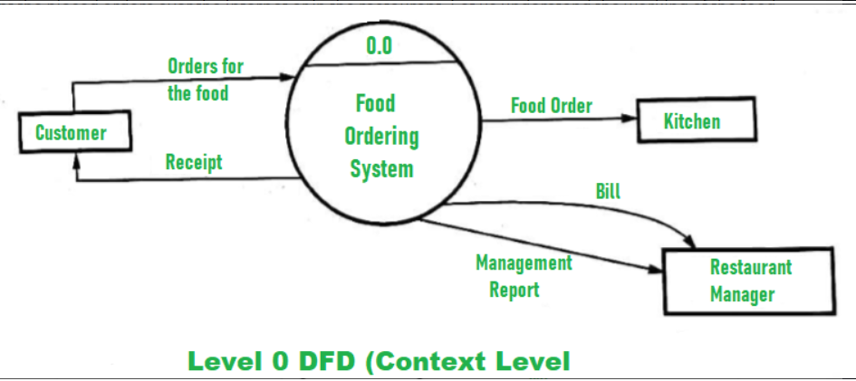

**Fig.3.1 0-level DFD**

**3.2 Use Case Diagram:**

Use Case Diagram gives a graphic overview of the actors involves in the system, different functions needed by those actors and how these different functions are interacted.

The purpose of this is to capture the dynamic aspect of a system. However, this definition is too generic to describe the purpose. Use Case Diagrams are used to gather the requirements of a system including internal and external influences. These requirements are mostly design requirements.

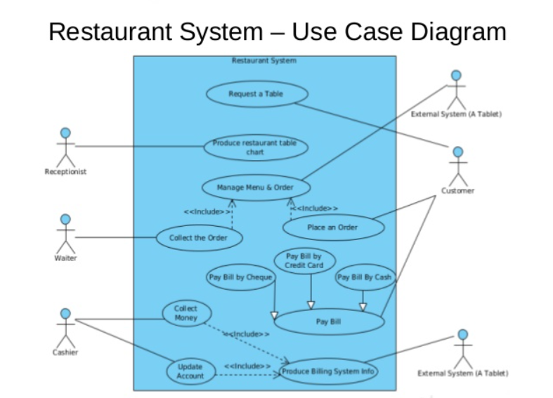

**Fig. 3.3 Use Case Diagram**

**3.3 E-R Diagram:**

Entity relationship diagrams are used in software engineering during the planning stages of the software project. They help to identify different system elements and their relationships with each other. In the diagram, the information inside the oval shapes are attributes of a particular entity. 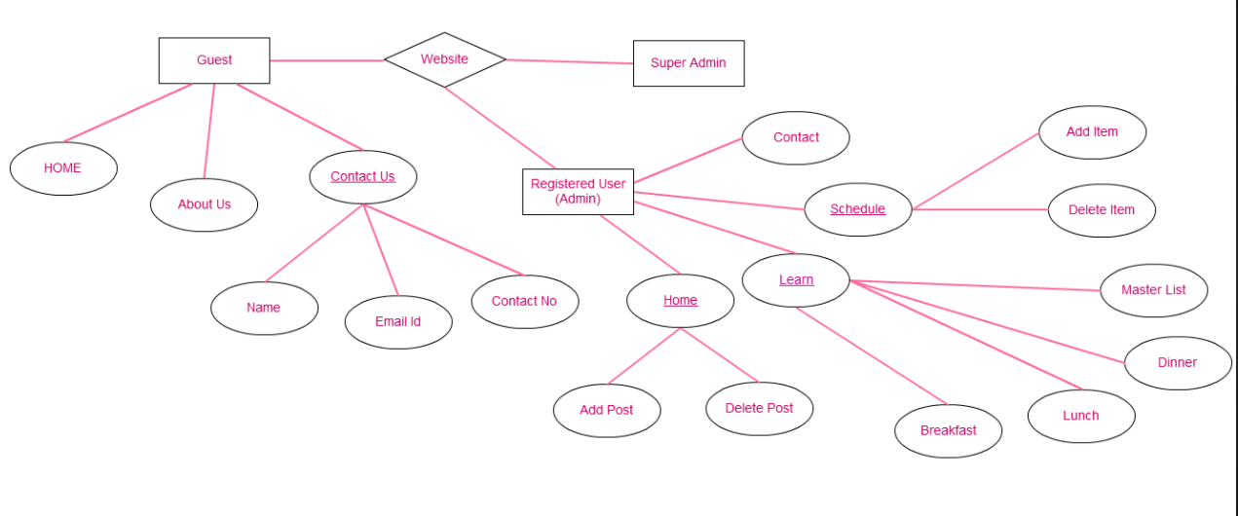

**Fig. 3.4 ER Diagram**

**CHAPTER-3**

**IMPLEMENTATION AND USER INTERFACES**

In this chapter we describe the various interfaces in the project like user interfaces, software interfaces and hardware interfaces. In the end output screens are shown depicting various screens in the system.

**4.1 User Interfaces:**

User interface is a part of software and is designed in such a way that it is expected to provide the user inside of the software. The UI provides fundamental platform for human-computer interaction. UI can be graphical, text based, audio-video based, depending upon the underlying hardware and software combination.

**4.2 Software Interfaces:**

3.1.a Front End: HTML, CSS, JavaScript

3.1.b Operating System: Windows 10

**4.3 Hardware Interfaces:**

3.2.a Processor: Intel CORE i5

3.2.b Hard Disk: 64 bits

3.2.c RAM: 8 GB

**4.4 Output Screens:**

**Front Page-**

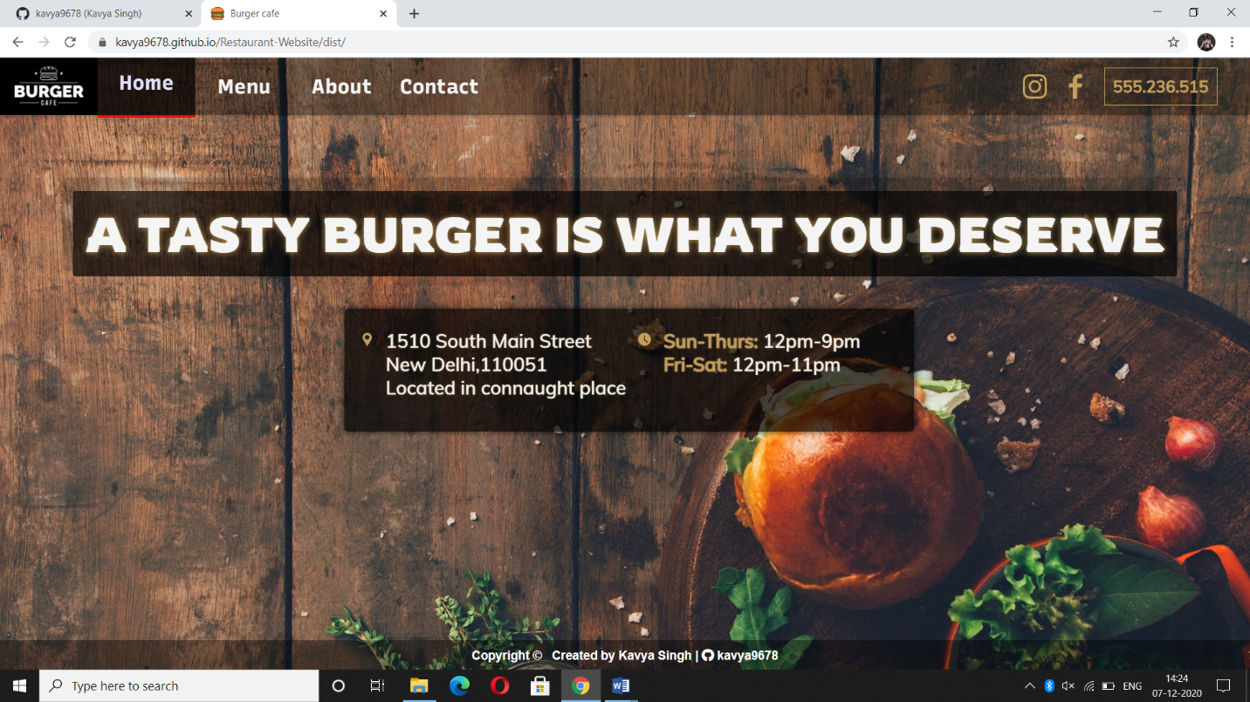

**Menu Page: (BURGERS & SANDWICHES)**

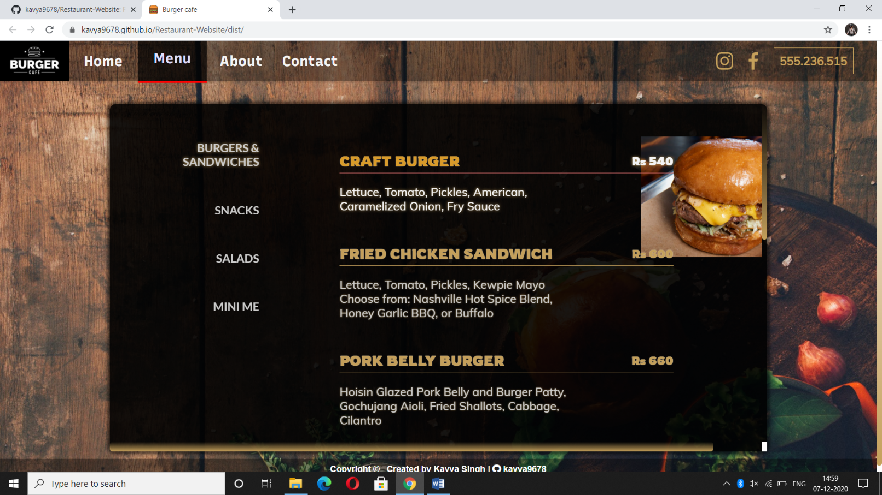

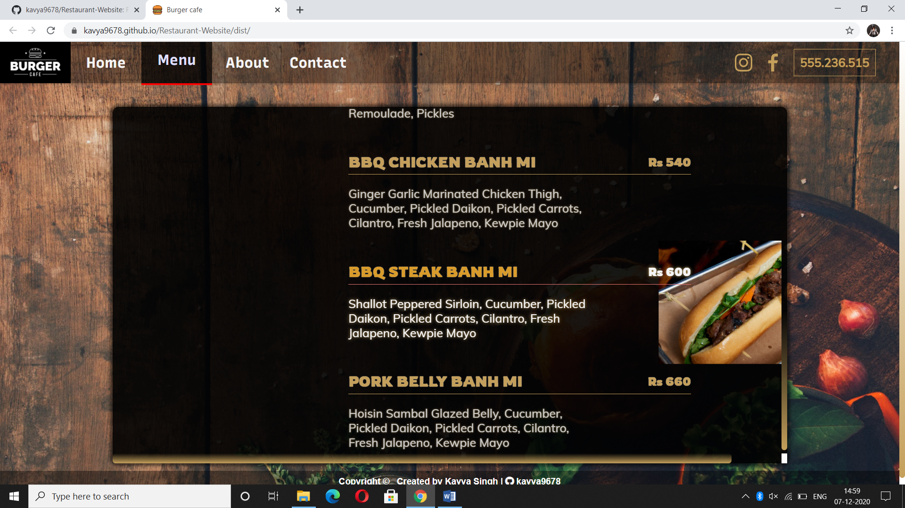

**Menu Page: (SNACKS)**

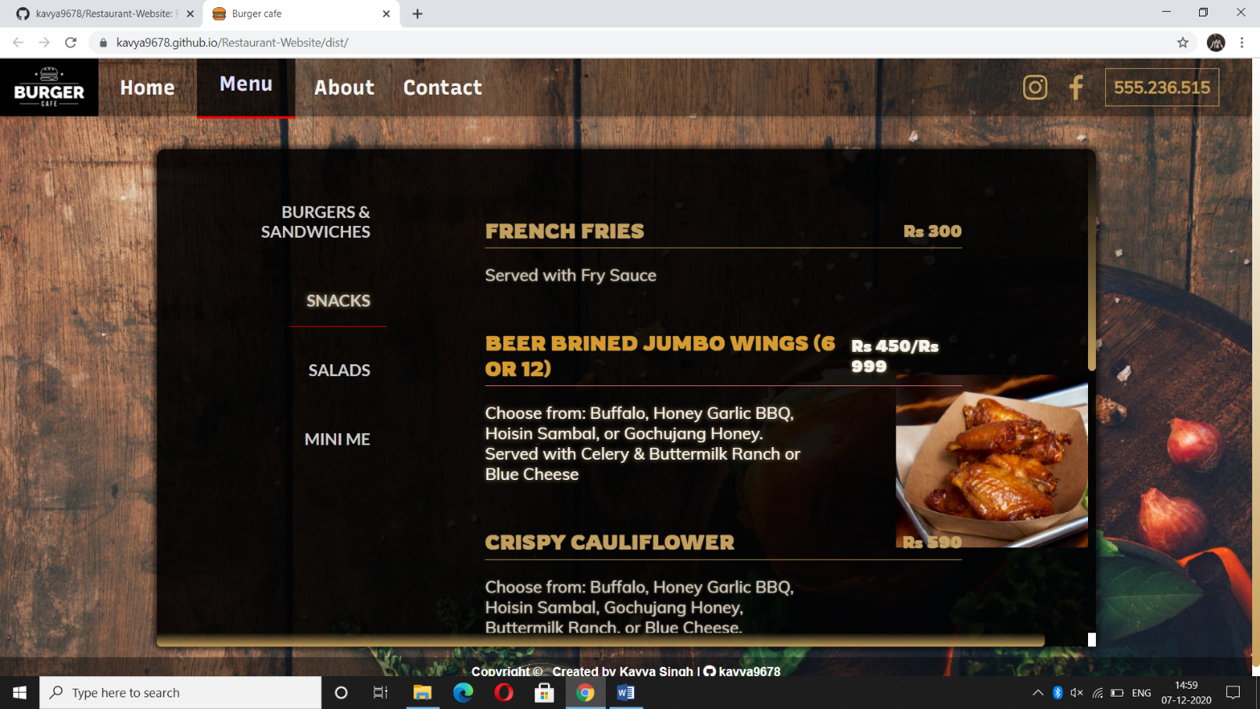

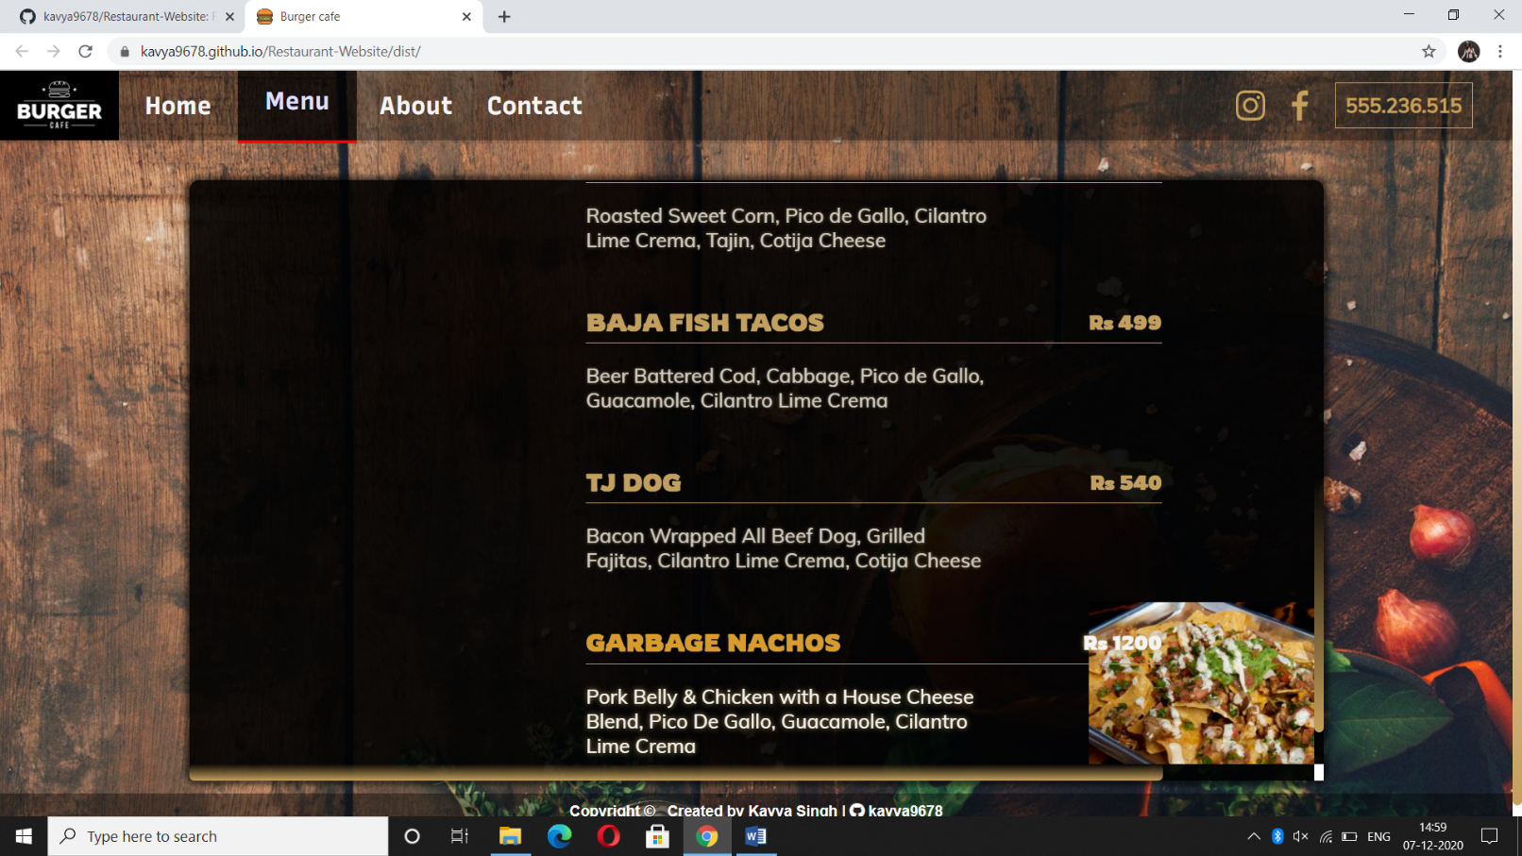

**Menu Page: (SALADS)**

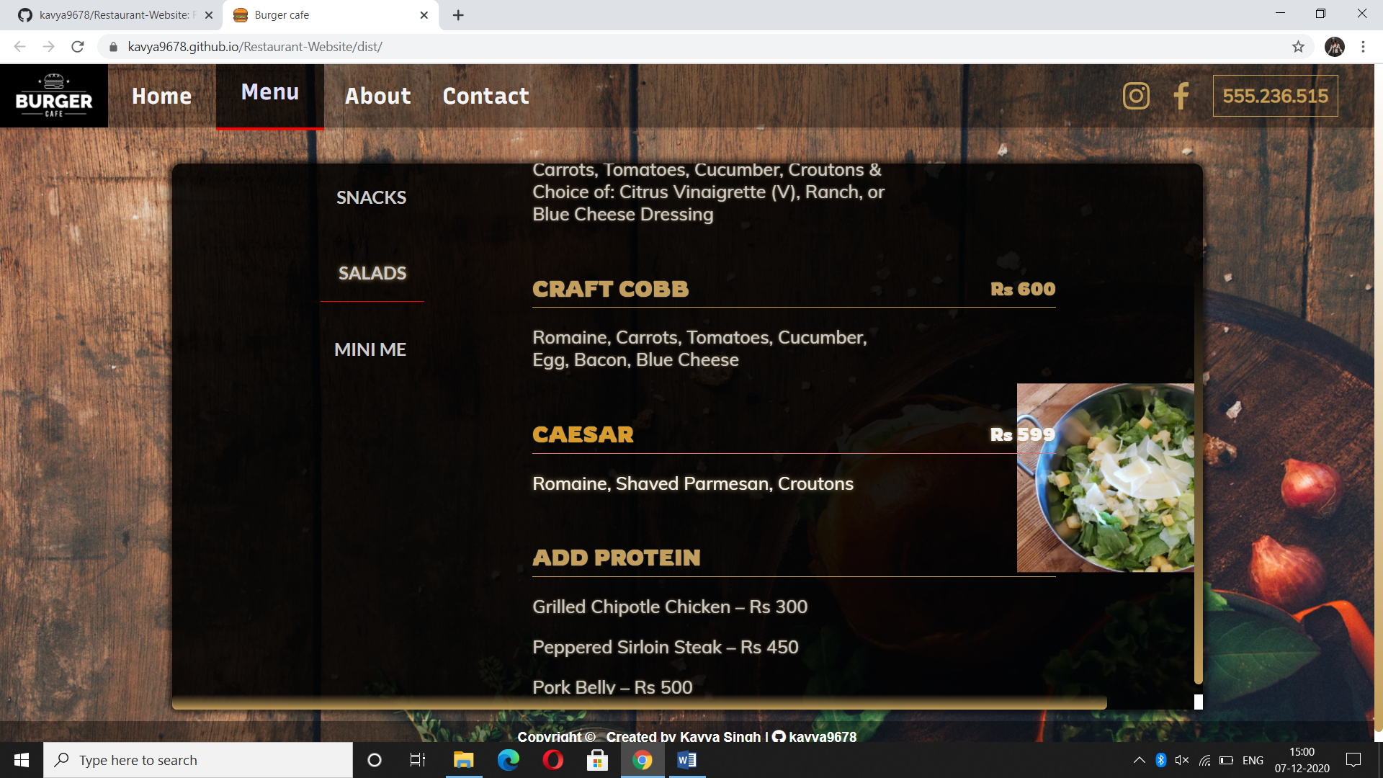

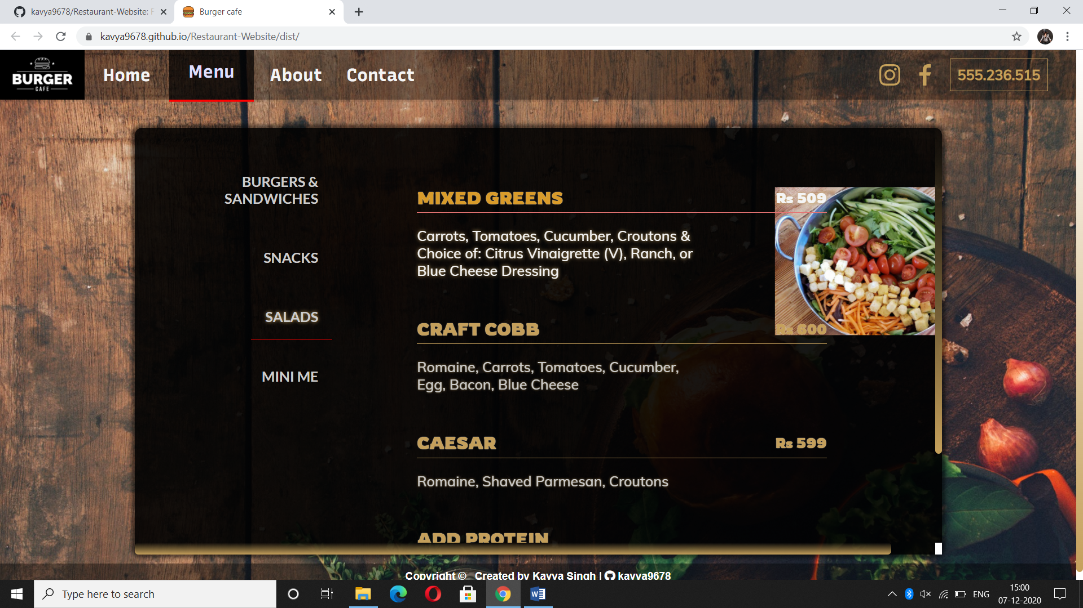

**Menu Page: (MINI MEAL)**

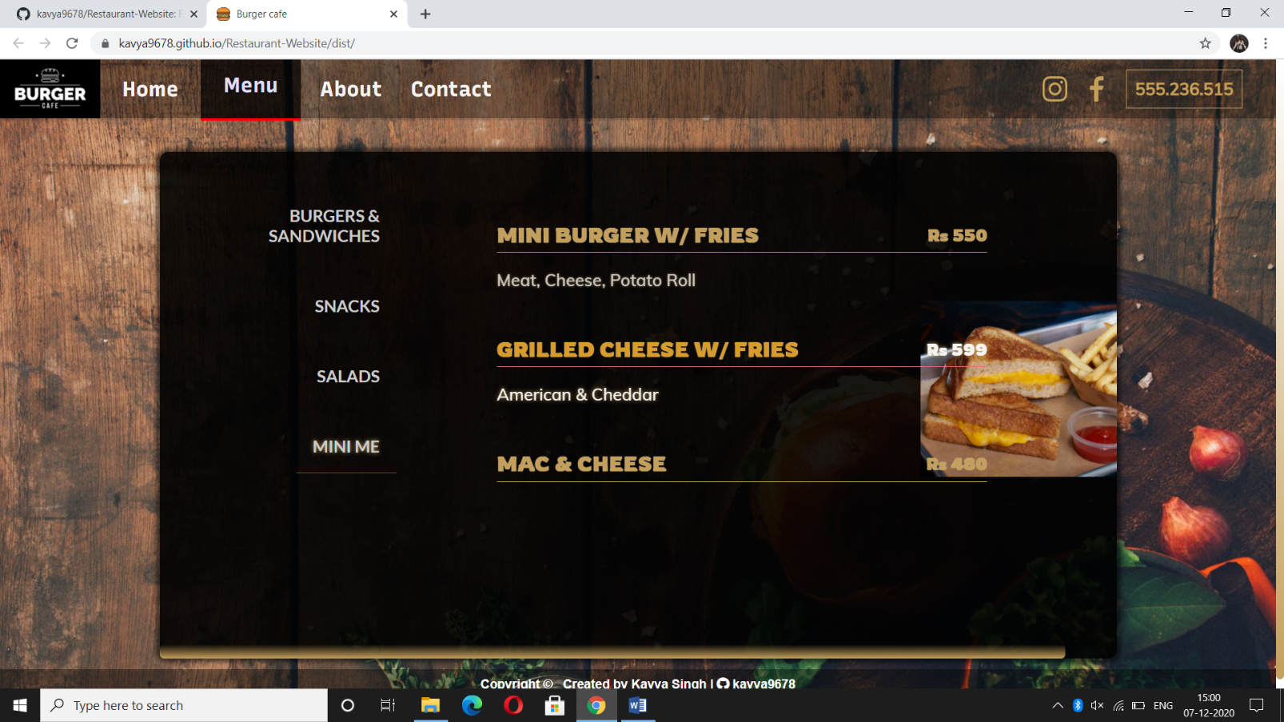

**About Page-**

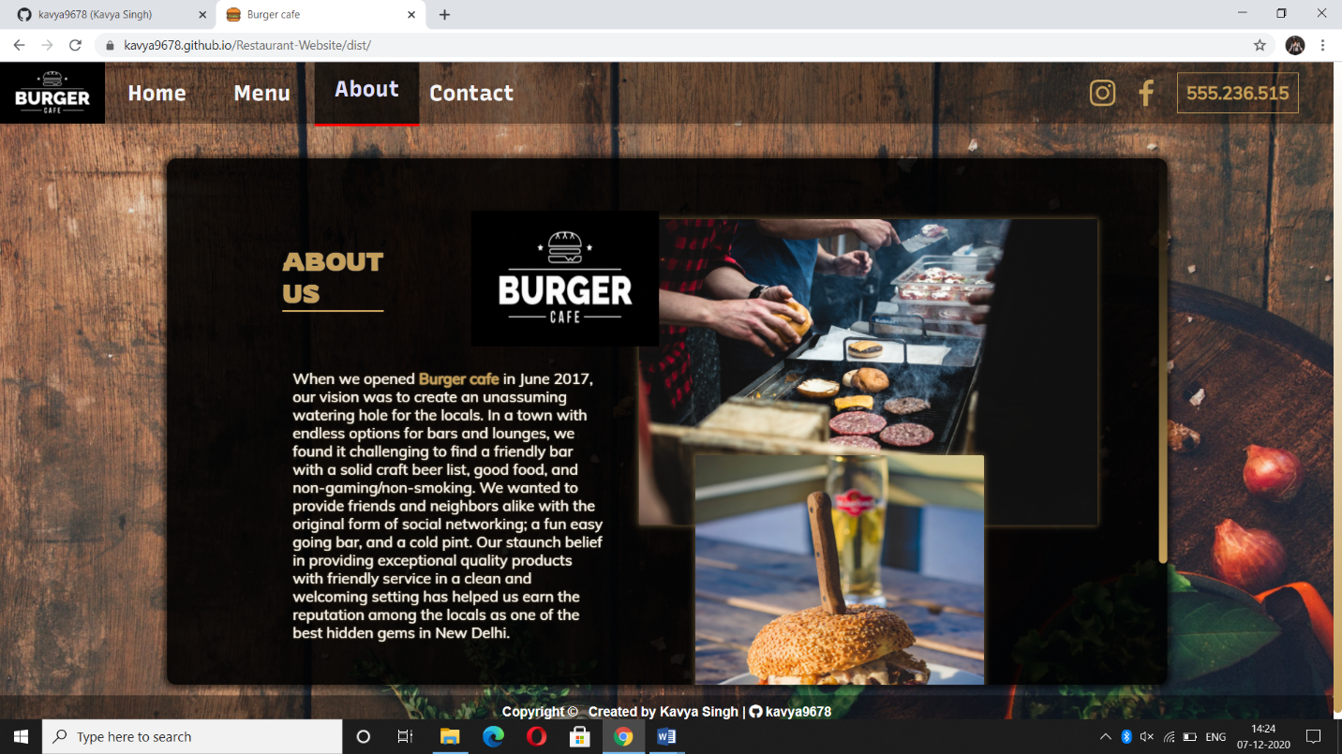

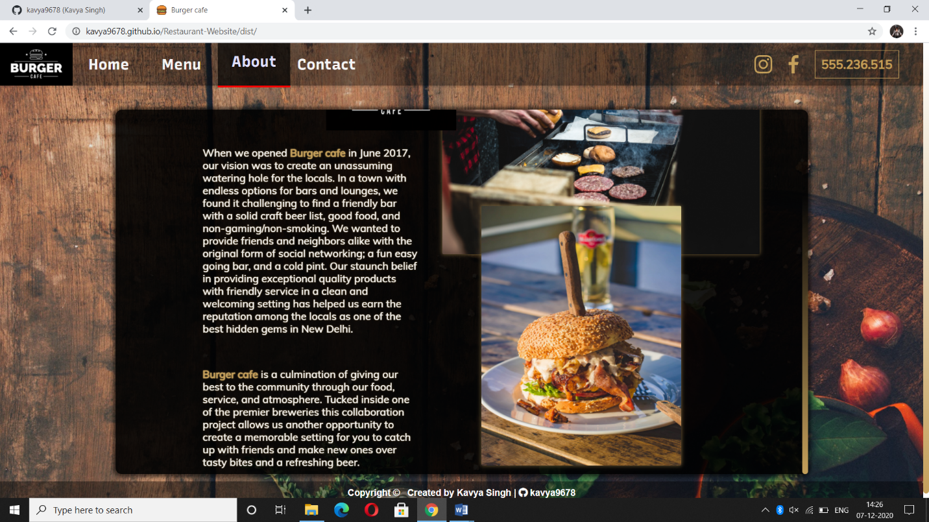

**Contact Page-**

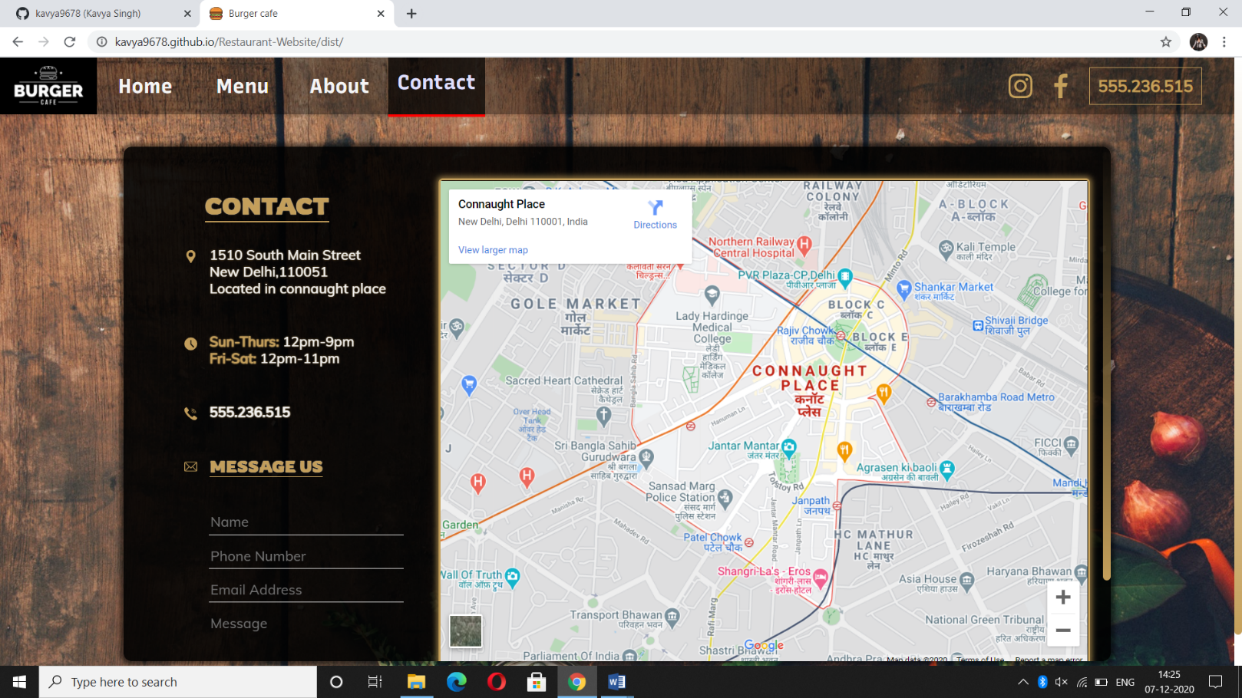

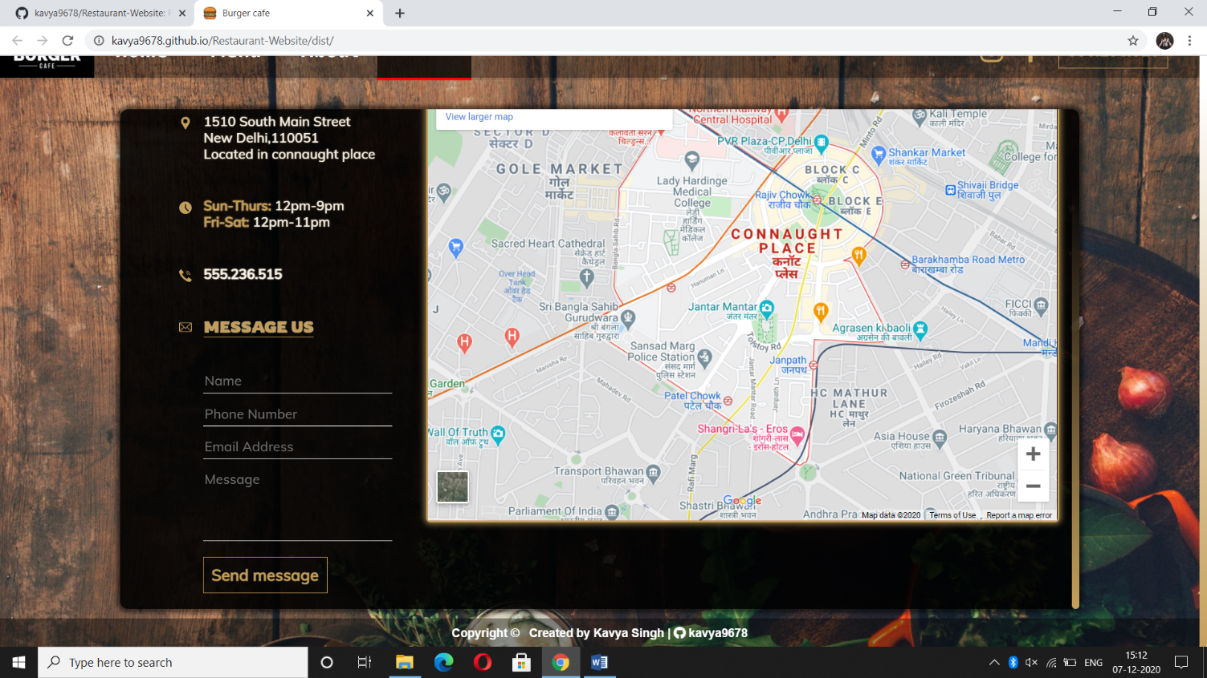

**EMAIL/CALL US:**

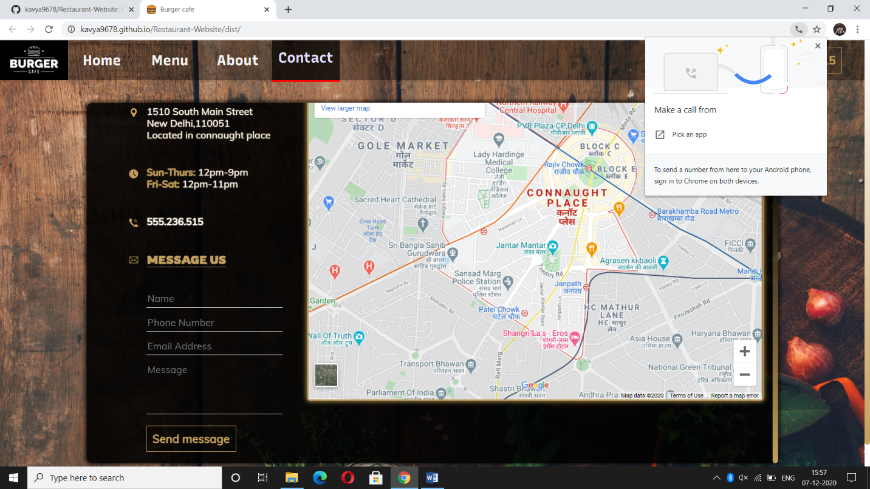

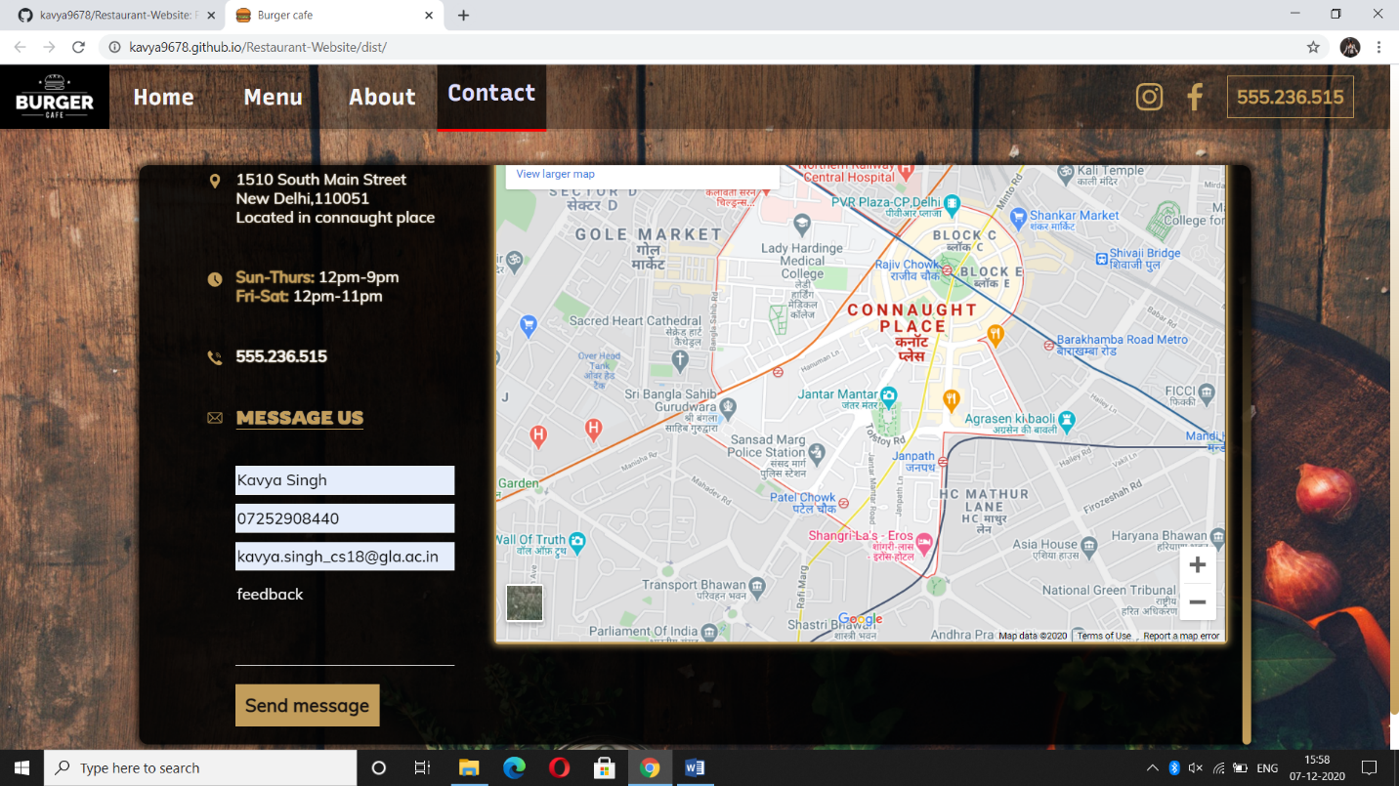

**INSTAGRAM,FACEBOOK PAGE:**

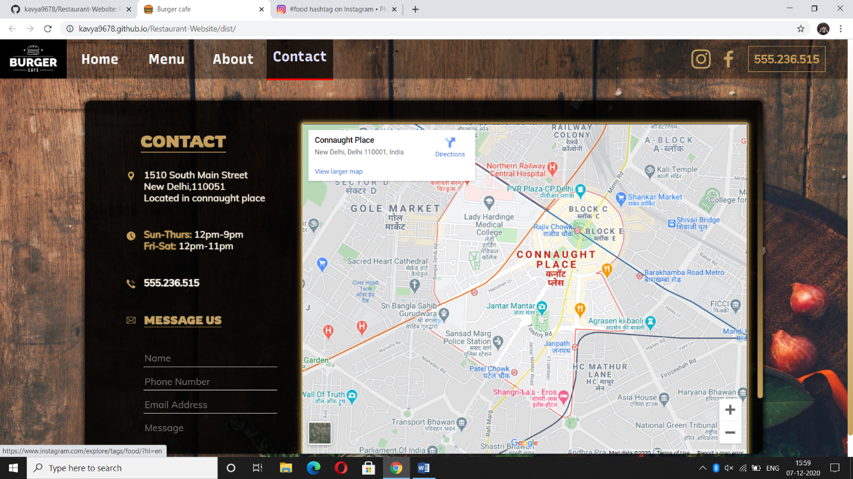

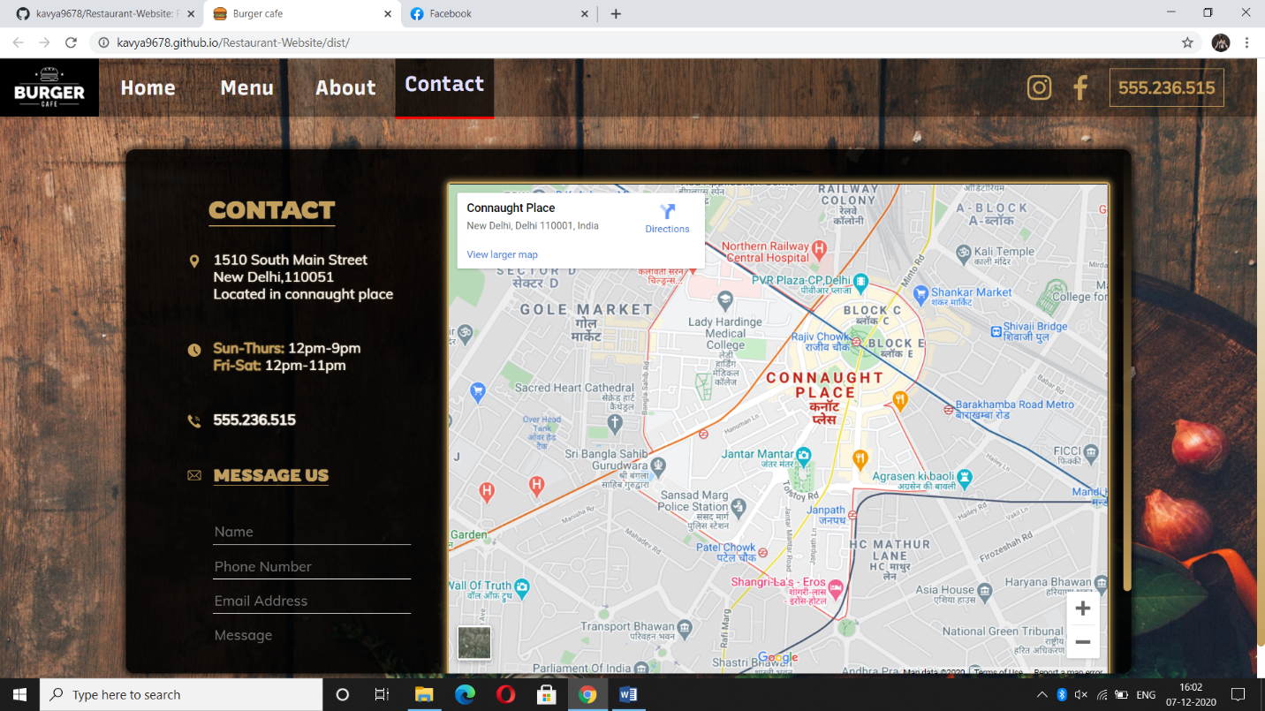

**SOME CODE SCREENSHORTS:**

**HTML:**

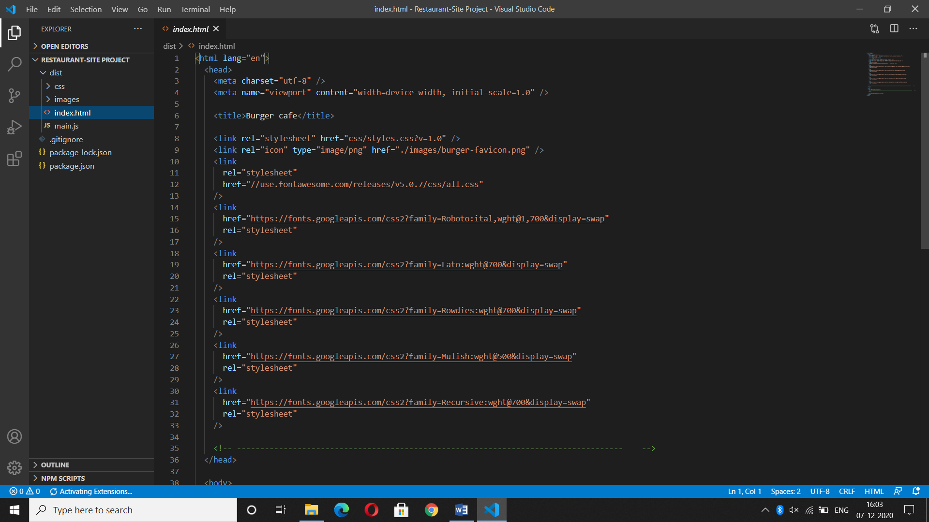

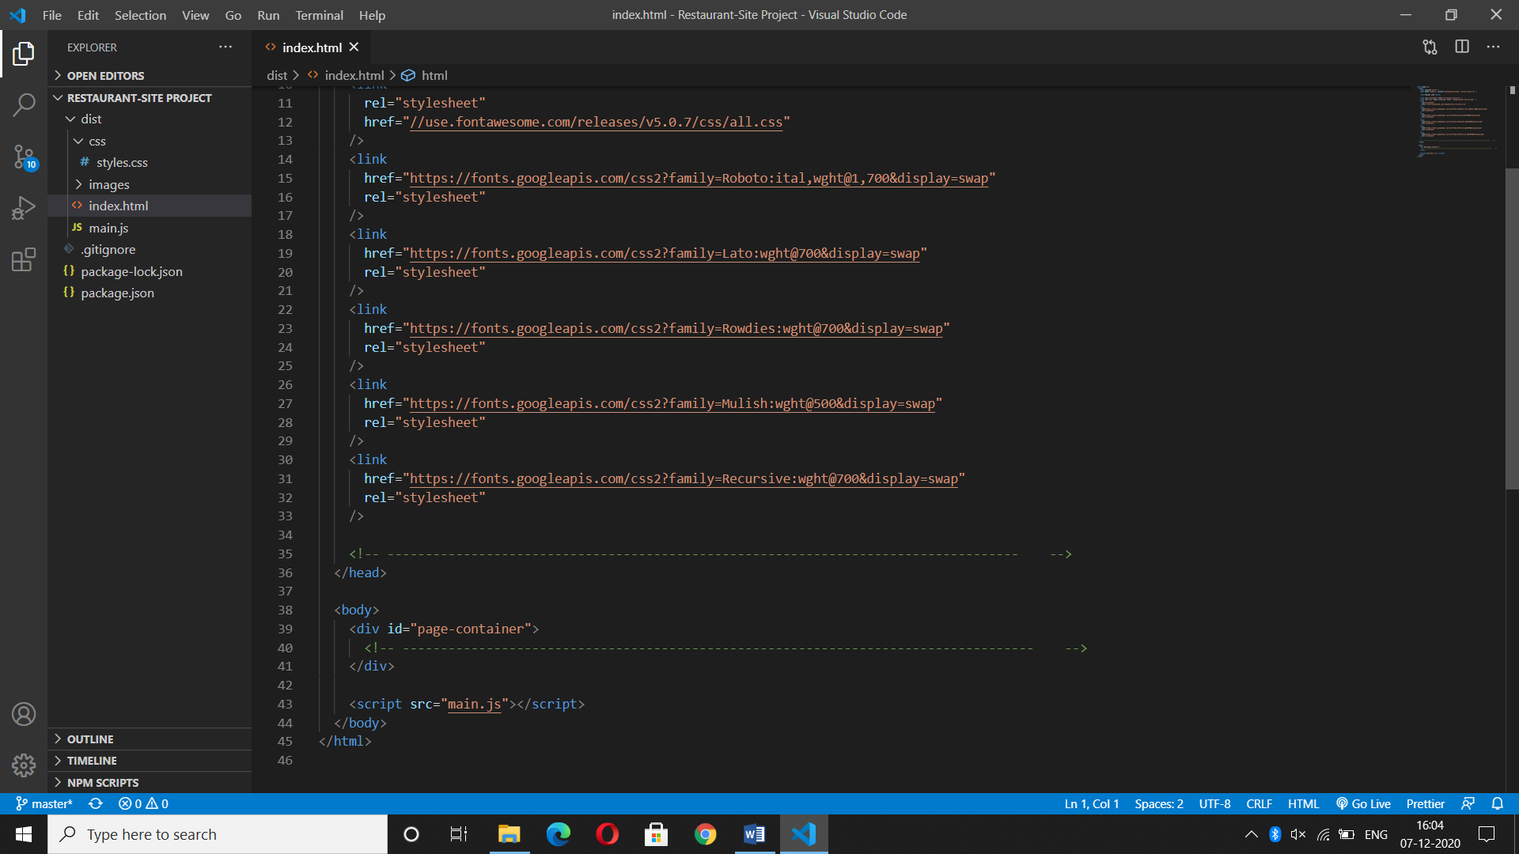

**CSS:**

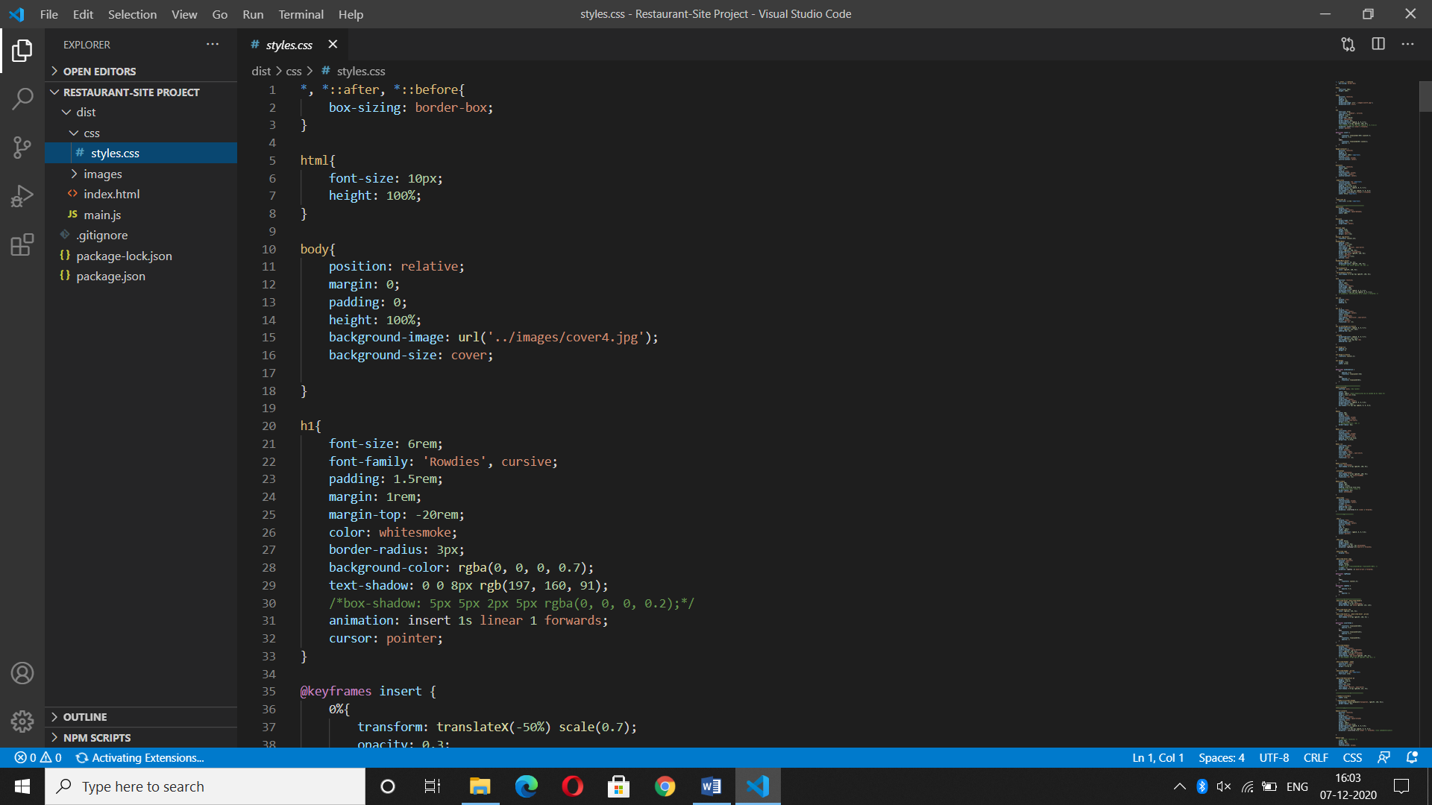

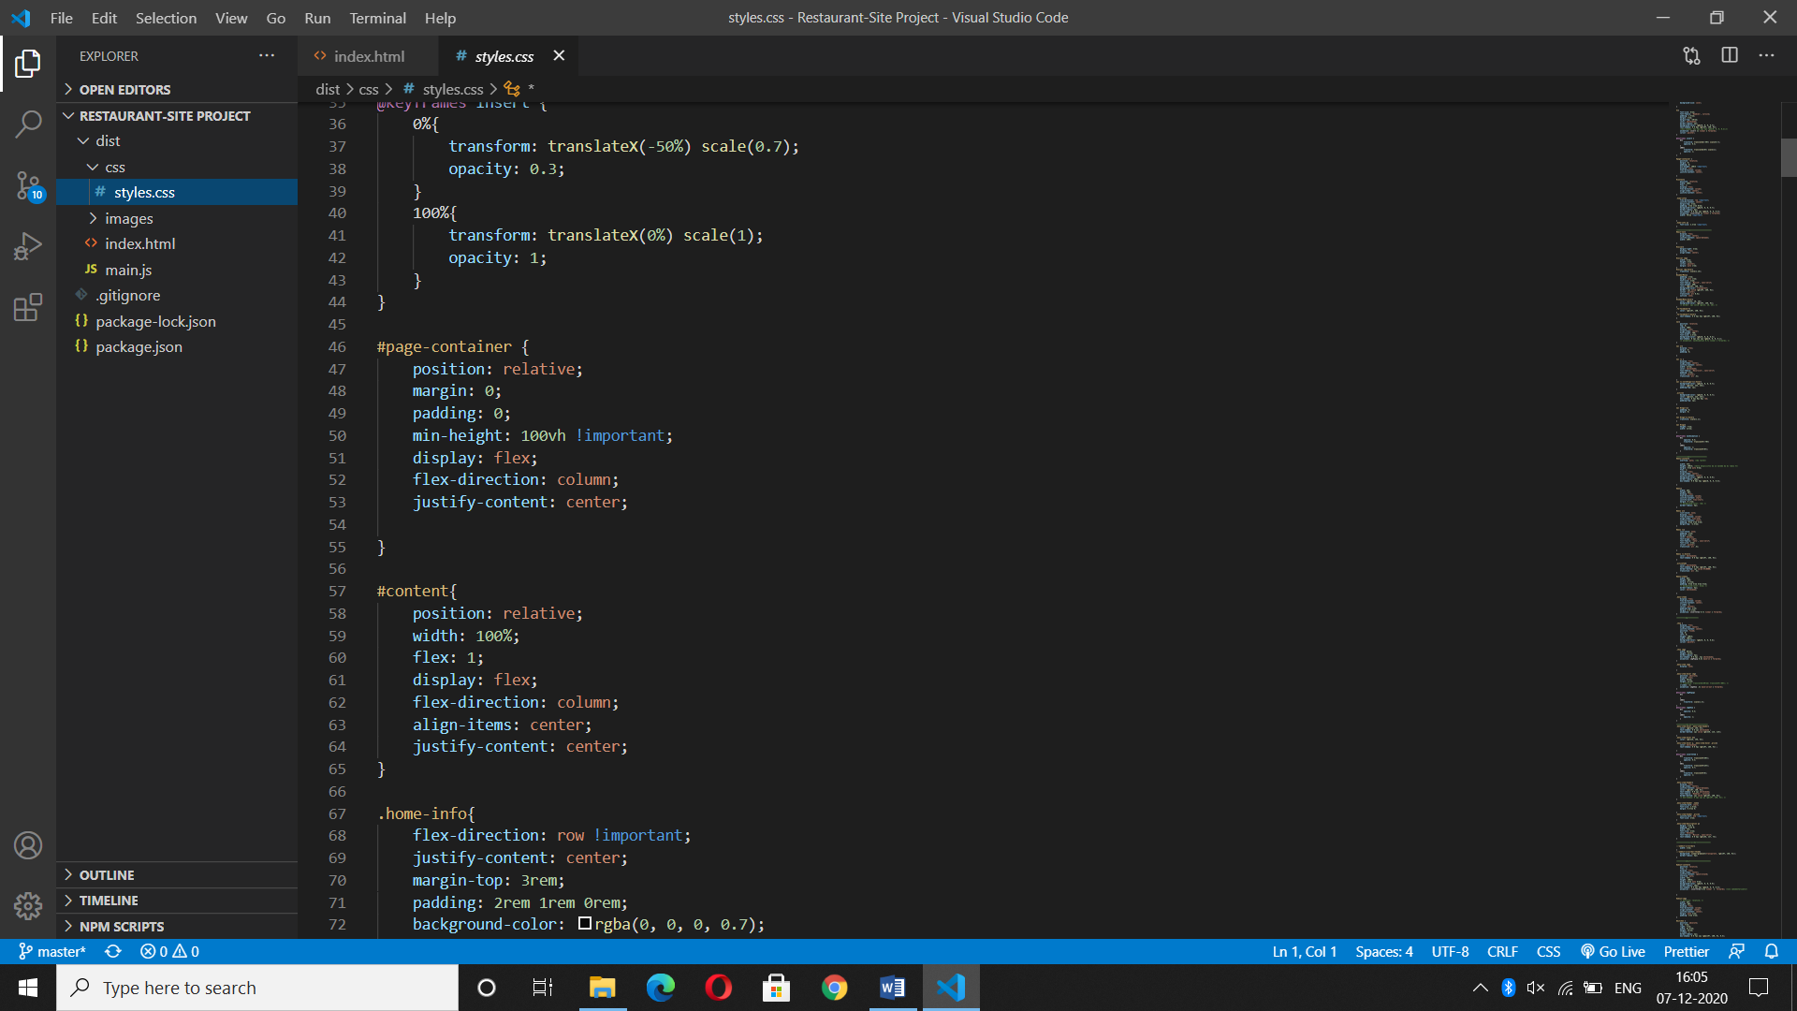

**JAVASCRIPT:**

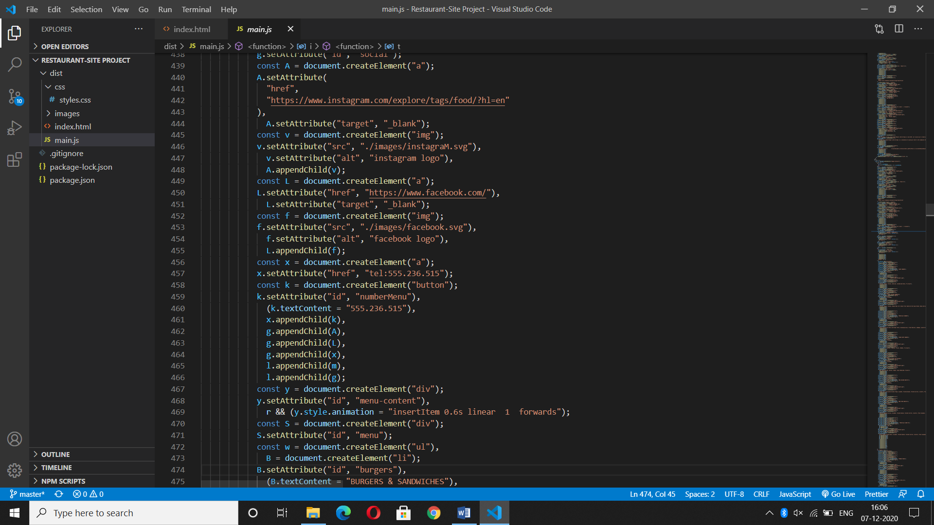

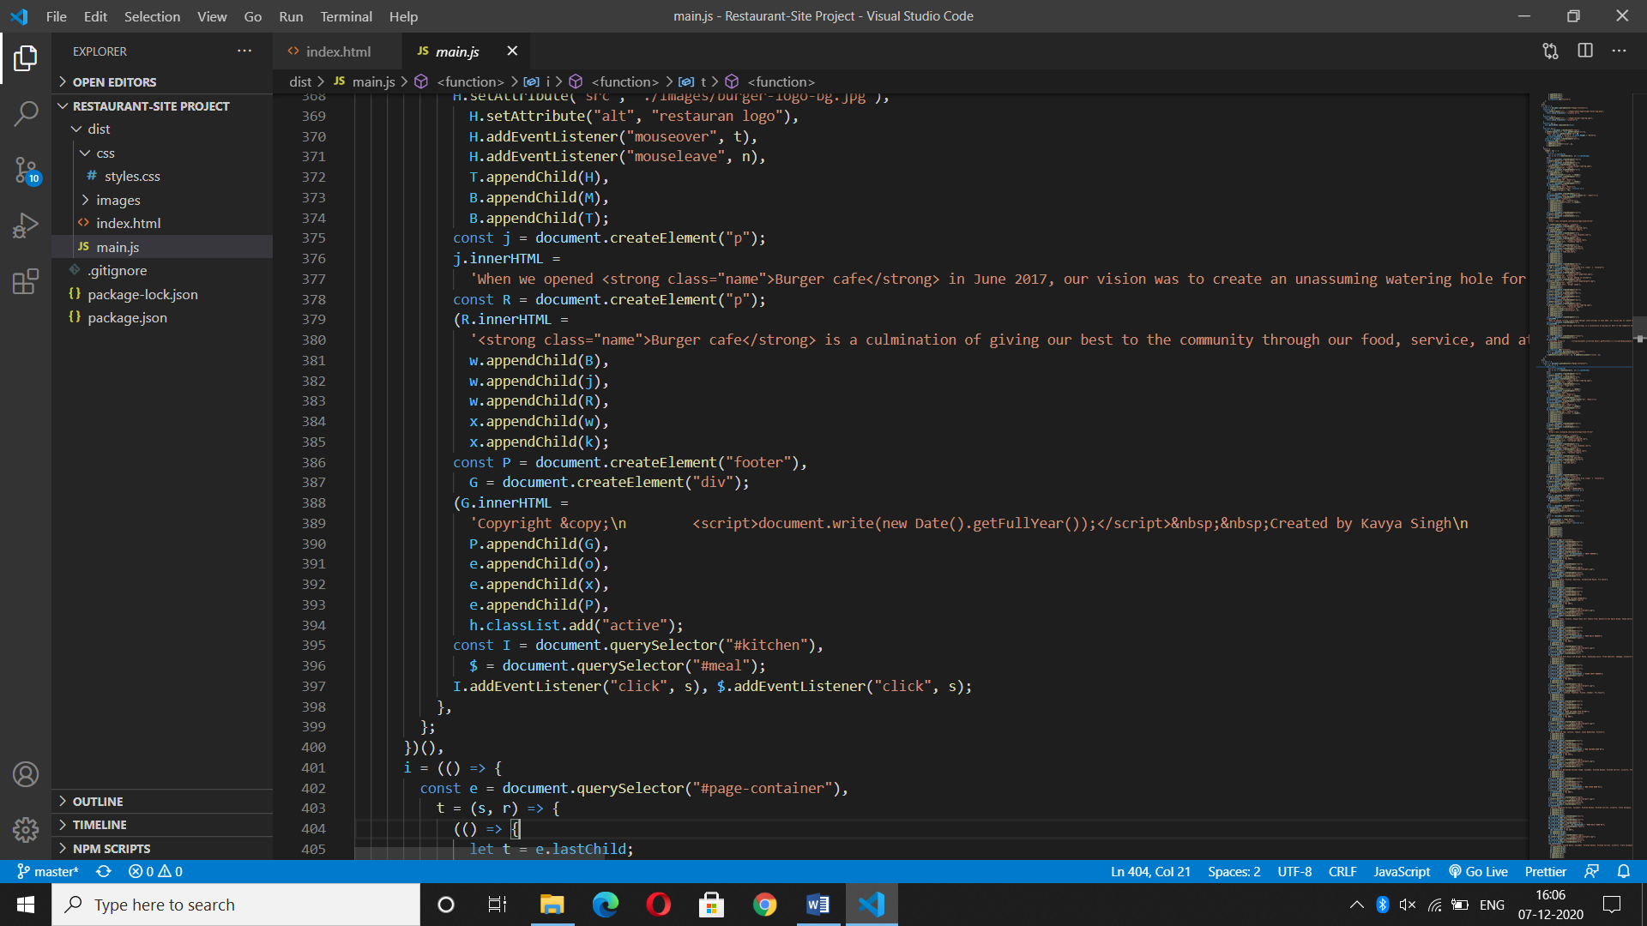

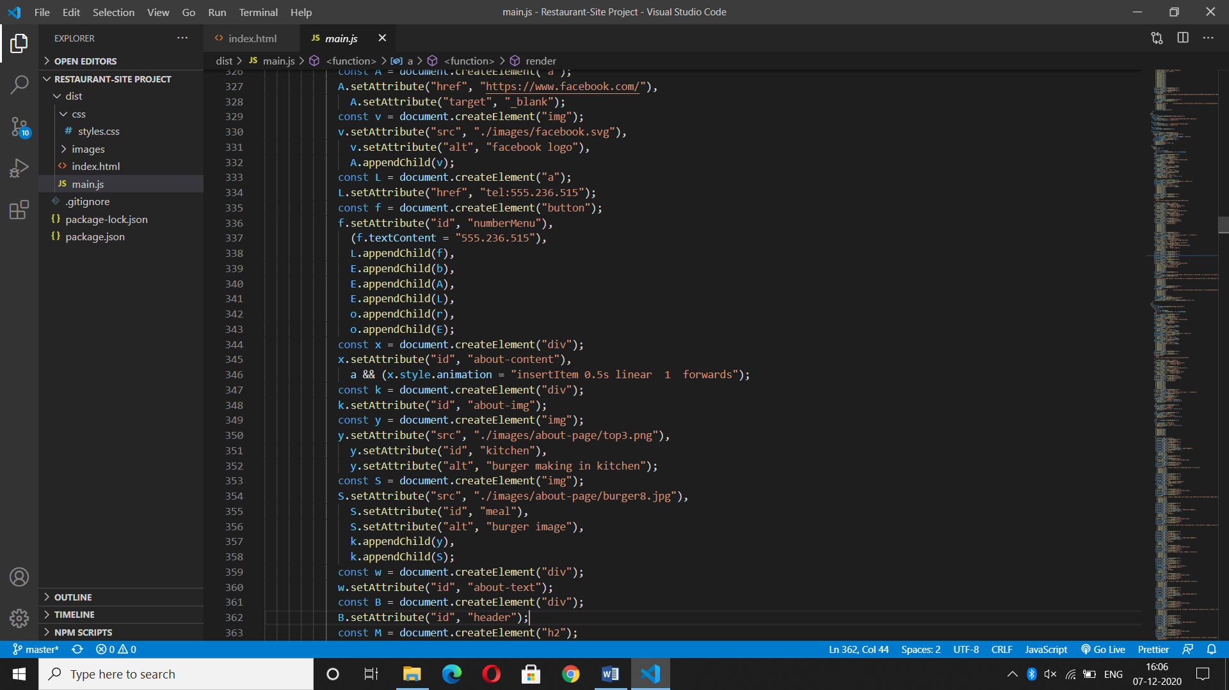

**CHAPTER-5**

**SOFTWARE TESTING**

Testing is one of the most import phases in the software development activity. In software development lifecycle (SDLC), the main aim of testing process is the quality: the developed software is tested against attaining the required functionality and performance.

During the testing process the software is worked with some particular test cases and the output of the test cases are analyzed whether the software is working according to the expectations or not.

**5.1 Introduction**

The success of the testing process is determining the errors which mostly depends upon the test case criteria, for testing any software we need to have a description of the expected behaviour of the system and method of determining whether the observed behaviour confirmed to the expected behaviour.

**Level of Testing:**

Since the errors in the software can be injured at any stage. So, we have to carry out the testing process at different level during the development. The basic levels of testing are Unit Integration, System Testing and Acceptance Testing.

The Unit Testing is carried out on coding. Here different modules are tested against the specifications produces during design for the modules. In case of Integration Testing different tested modules are combined into sub systems and tested. In case of the system testing the full software is tested and in the next level of testing the system is tested with user requirement document prepared during SRS.

There are two basic approaches for testing. They are:

**Functional Testing:**

In functional testing test cases are decided solely on the basis of requirements of the program or the module and the internals of the program or modules are not considered for selection of test cases. This is also called Black Box Testing.

**Structural Testing:**

In Structural Testing test cases are generated on actual code of the program or module to be tested. This is called White Testing.

**5.2 Testing Process**

A number of activities must be performed for testing software. Testing starts with test plan. Test plan identifies all testing related activities that need to be performed along with the schedule and guide lines for testing. The plan also specifies the levels of testing that need to be done, by identifying the different testing units. For each unit specified in the plan first the test cases and reports are produced. These reports are analyzed.

**Test plan:**

Test plan is a general document for entire project, which defines the scope, approach to be taken and the personal responsible for different activities of testing. The inputs for forming test plans are:

Project plan

Requirements documents

System design

**Test Case Specification:**

Although there is one test plan for entire project test cases have to be specified separately for each test case. Test case specification gives for each item to be tested. All test cases and outputs expected for those test cases.

**Test Case Execution and Analysis:**

The steps to be performed for executing the test cases are specified in separate document called test procedure specification. This document specify any specify requirements that exist for setting the test environment and describes the methods and formats for reporting the results of testing.

**Unit Testing:**

Unit testing mainly focused first in the smallest and low level modules, proceeding one at a time. Bottom-up testing was performed on each module. As developing a driver program, that tests modules by developed or used. But for the purpose of testing, modules themselves were used as stubs, to print verification of the actions performed. After the lower level modules were tested, the modules that in the next higher level those make use of the lower modules were tested.

Each module was tested against required functionally and test cases were developed to test the boundary values.

**Integration Testing:**

Integration testing is a systematic technique for constructing the program structure, while at the same time conducting tests to uncover errors associated with interfacing. As the system consists of the number of modules the interfaces to be tested were between the edges of the two modules. The software tested under this was incremental bottom-up approach.

Bottom-up approach integration strategy was implemented with the following steps.

* Low level modules were combined into clusters that perform specific software sub fractions.
* The clusters were then tested.

**System Testing:**

System testing is a series of different tests whose primary purpose is to fully exercise the computer based system. It also tests to find discrepancies between the system and its original objective, current specifications.

**System Test Cases and System Test Report:**

The System Test Cases mentioned below are expected to work and give the expected behavior if the explorer is configured to run jar files.

**CHAPTER-6**

**CONCLUSION**

The project entitled “RESTAURANT WEBSITE “has been proposed to be implementing to replace the manual system. The developed system accomplishes all the objectives stated for the need for the change of the system. The outputs produced seem to satisfy all the users but it will definitely take to look forwarded for the real consequences the new system could produce. This project was made user friendly. It’s also enabled the platform to serve the needs of emerging information technology trends and needs.

**REFERENCES**

* [www.w3schools.com](http://www.w3schools.com)
* [https://www.geeksforgeeks.org](https://www.geeksforgeeks.org/)
* [https://www.tutorialspoint.com](https://www.tutorialspoint.com/)
* [www.quora.com](http://www.quora.com)
* <https://www.slideshare.net>
* www.stackoverflow.com
* [www.nevonprojects.com](http://www.nevonprojects.com)
* [www.slideshare.net](http://www.slideshare.net/)
* [www.academis.edu](http://www.academis.edu/)
* <https://getbootstrap.com>
* https://github.com/simonbengtsson/jsPDF-AutoTable